Purpose:

This workflow describes how vendors can use the Prodomax Purchasing Portal to respond to Requests for Quotation or Purchase Orders.

Logging In:
- Open you web browser and navigate to portal.prodomax.com
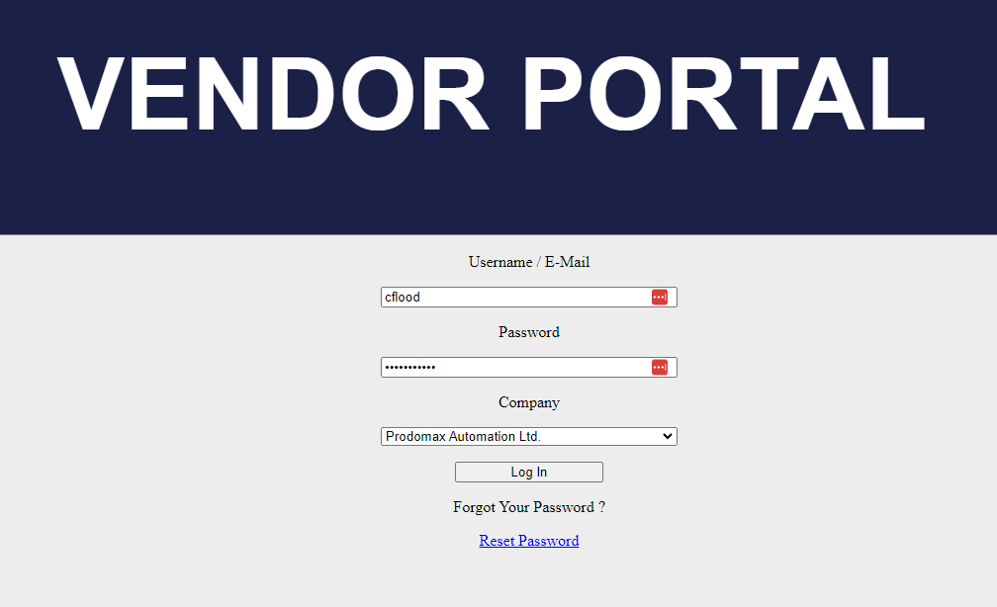
- Enter your username and password. These will be provided to you from Prodomax after initial setup of the portal.
- Click the Log In button.
Note: there is a reset password function on the login screen. You will be prompted to enter your username or email. An email will be sent to the address on file for the account with a password reset link.

Request For Quotation
- Log into the portal as shown above.
- From the home screen, select RFQs either in the header of the page or from the center of the page.
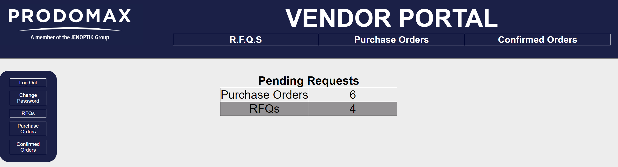
- Select an RFQ from the list.
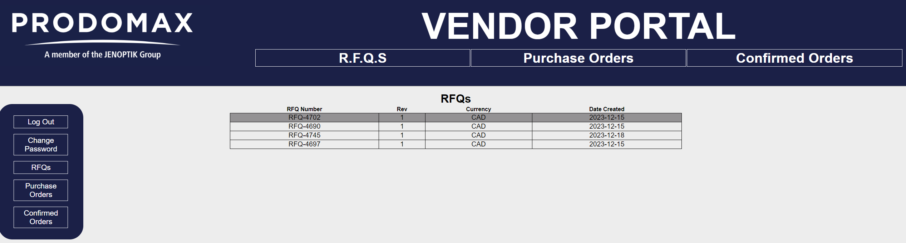
- Enter the unit price for each line item.
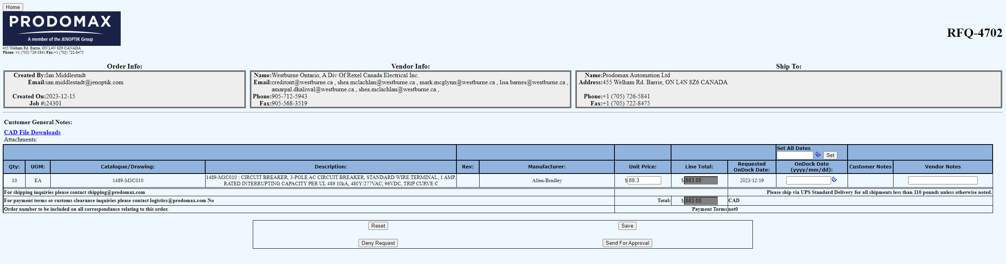
- Enter the promised delivery date into the On Dock Date field for each item.
  - You can set all delivery dates at once using the Set All Dates feature in the header of the table.
- Click Send For Approval. This will return the completed RFQ back to Prodomax.
- The RFQ should no longer be in your list of RFQs now that it has been answered.
Note: There are also buttons to reset the quote (clear all entered values), to save the quote (to come back and finish later) or deny request (refuse to quote).

Purchase Order
- Log into the portal as shown above.
- From the home screen, select POs either in the header of the page or from the center of the page.
- Select a PO from the list.
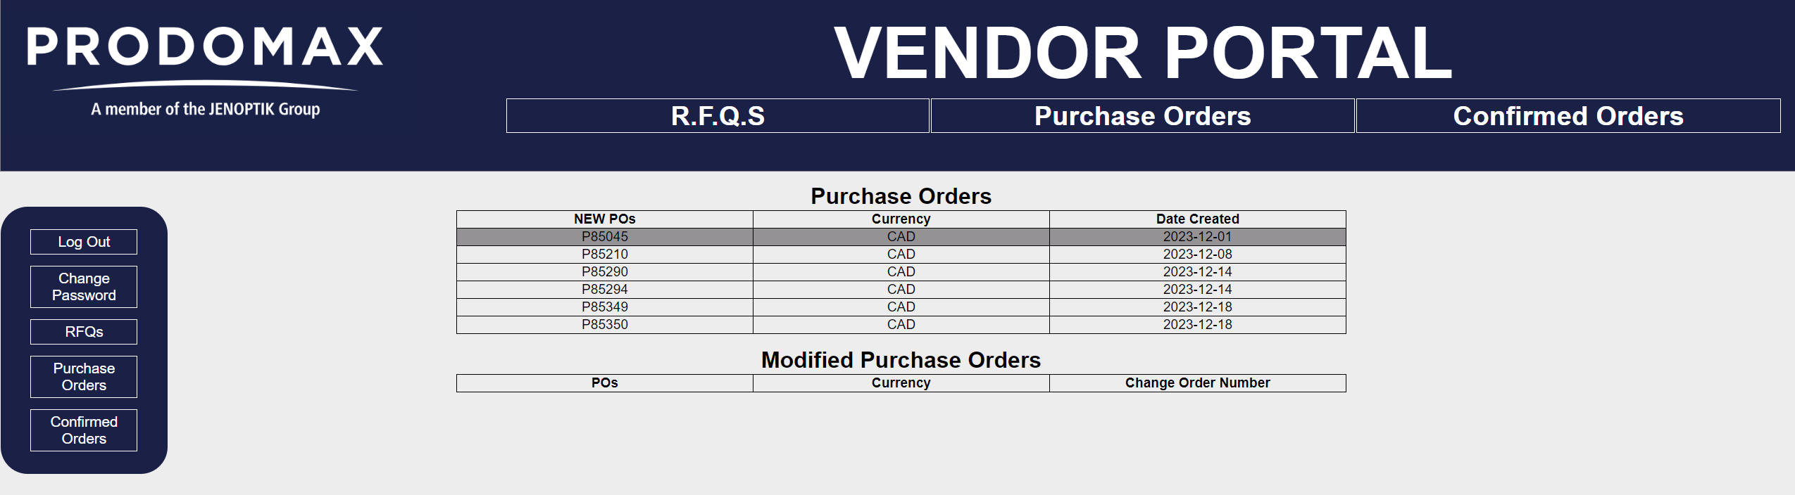
- Review the PO information.
- To confirm the PO, click the acknowledge button at the top of the page.
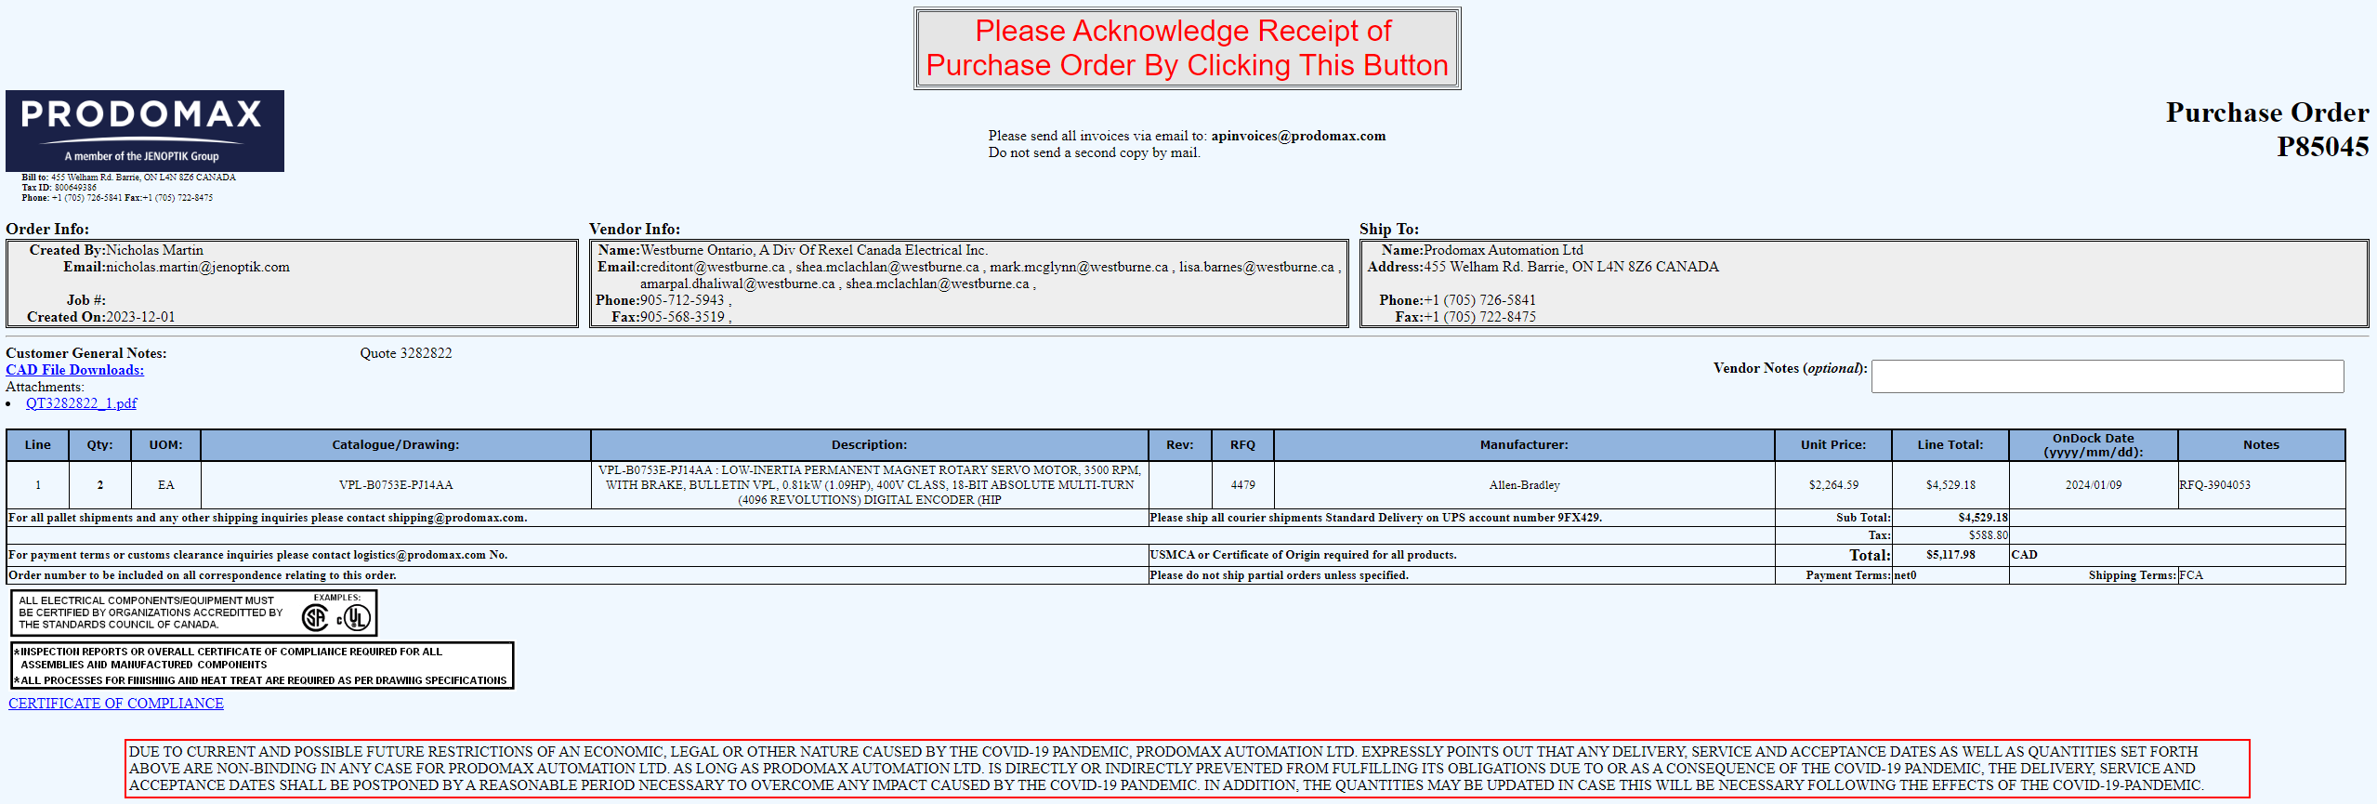
- The PO will now be visible in the Confirmed Orders section of the portal.

